Web Design

and

Development Essay

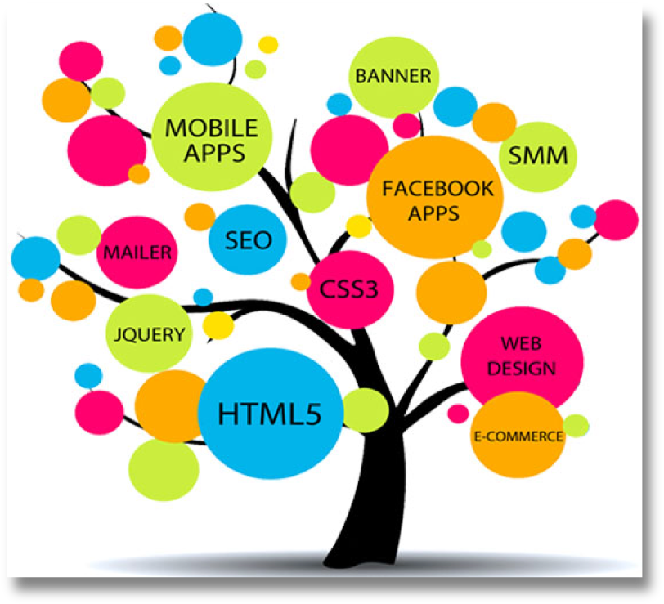
Samantha Thun
WDD100 - 9

Things I’ve Learned Through Intro to Web Design

Reading through these articles helped clarify some details about the many different directions that a degree in web design/development can take you. One of the main things that stood out to me across the three articles was the “Pay by Experience Level” charts. It showed that over time and with experience in any of the three routes there’s potential for increase in pay. It’s helpful to know that as you continue on in your career, things can improve as long as you are keeping up with the ever-changing technology world.
The aspect of web design/development that I’m leaning toward is the web designer route. I like being able to take information given to me and organizing it. I feel like if I can develop my understanding more of the important scopes of web design (html, CSS, JavaScript), I’ll be headed in the right direction. One of my main reasons for choosing this major is so that I can potentially work from home for the majority of the job assignments. As a mother with young children still, I’d like to be present as much as possible for them, but still be able to have a “hobby” for me.
In general, I felt like this class was able to teach me the process of organizing a webpage properly. It was helpful to go through setting up the rafting webpage step by step each week by adding certain designs or formats to make a successful and tasteful site. I had never dealt with CSS before this class, so I was able to begin learning that side of designing to help improve the aesthetic of a webpage. I feel like I was only able to scratch the surface with CSS, but it’s a foundation that I hope to continue to build upon throughout my studying. (309 words)

